**Initial Project Planning Template**

|  |  |
| --- | --- |
| Date | 1 JULY 2025 |
| Team ID | LTVIP2025TMID47423 |
| Project Name | Measuring the Pulse of Prosperity: An Index of Economic Freedom Analysis |
| Maximum Marks | 4 Marks |

**Product Backlog, Sprint Schedule, and Estimation (4 Marks)**

Use the below template to create a product backlog and sprint schedule

|  |  |  |  |  |  |  |  |  |
| --- | --- | --- | --- | --- | --- | --- | --- | --- |
| **Sprint** | **Functional**  **Requirement (Epic)** | **User Story Number** | **User Story / Task** | **Story Points** | **Priority** | **Team Members** | **Sprint Start Date** | **Sprint End**  **Date**  **(Planned)** |
| Sprint-1 | Data  Collection & Extraction from Database | TSK-519920 | Downloading the dataset | 2 | High | K geethika | 14-6-2025 | 15-6-2025 |
| Sprint-1 | Data  Preparation | TSK-519921 | Explanation video links | 1 | High | Jala Praneeth | 15-6-2025 | 16-3-2025 |

|  |  |  |  |  |  |  |  |  |
| --- | --- | --- | --- | --- | --- | --- | --- | --- |
| **Sprint** | **Functional**  **Requirement (Epic)** | **User Story Number** | **User Story / Task** | **Story Points** | **Priority** | **Team Members** | **Sprint Start Date** | **Sprint End**  **Date**  **(Planned)** |
| Sprint-2 | Data  Visualization | TSK-519922 | No. of Unique Visualizations | 2 | Low | K S Noor ahamad | 17-6-2025 | 18-6-2025 |
| Sprint-2 | Data  Visualization | TSK-51992331 | Visualizations | 2 | High | K S Noor ahamad | 18-6-2025 | 21-6-2025 |
| Sprint-3 | Dashboard | TSK-519932 | Responsive and Design of Dashboard | 1 | High | geethika | 21-6-2025 | 22-6-2025 |
| Sprint-3 | Story | TSK-  519935 | No of Scenes of Story | 2 | High | Prakash babu | 22-6-2025 | 23-6-2025 |
| Sprint-3 | Story | TSK-  519936 | Utilization of Filters | 1 | Medium | Praneeth kumar | 24-6-2025 | 25-6-2025 |
| Sprint-4 | Web  integration | TSK-  519937 | Go to Dashboard/story, click on share button on the top ribbon | 2 | Medium | geethika | 26-6-2025 | 28-6-2025 |
| Sprint-4 | Web  integration | TSK-  519938 | Dashboard and Story embed with UI  With Flask | 2 | High | Noor Ahamad | 28-3-2025 | 30-6-2025 |

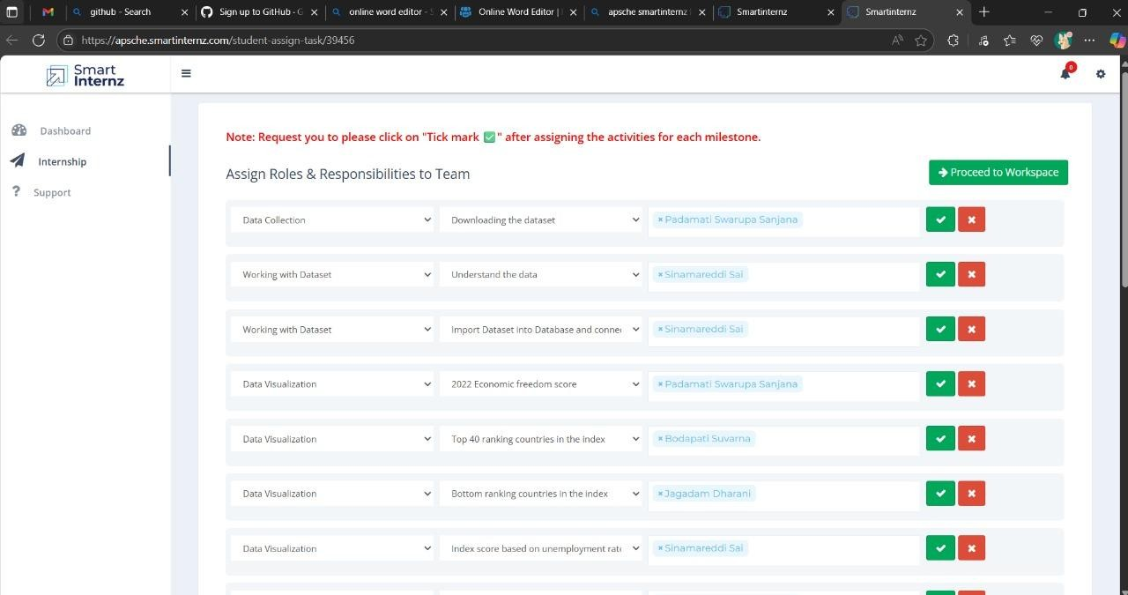

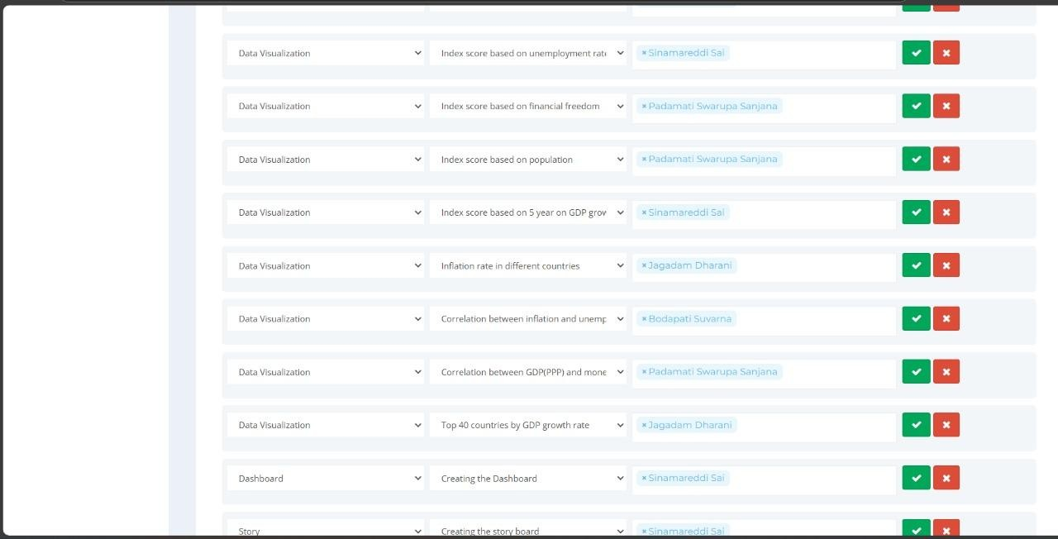

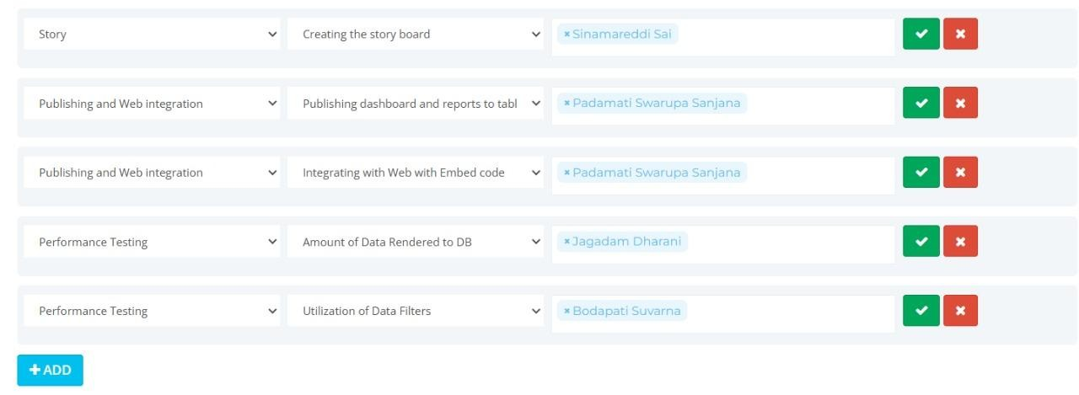

This is our project file how we are do the project